Use Case Diagram:

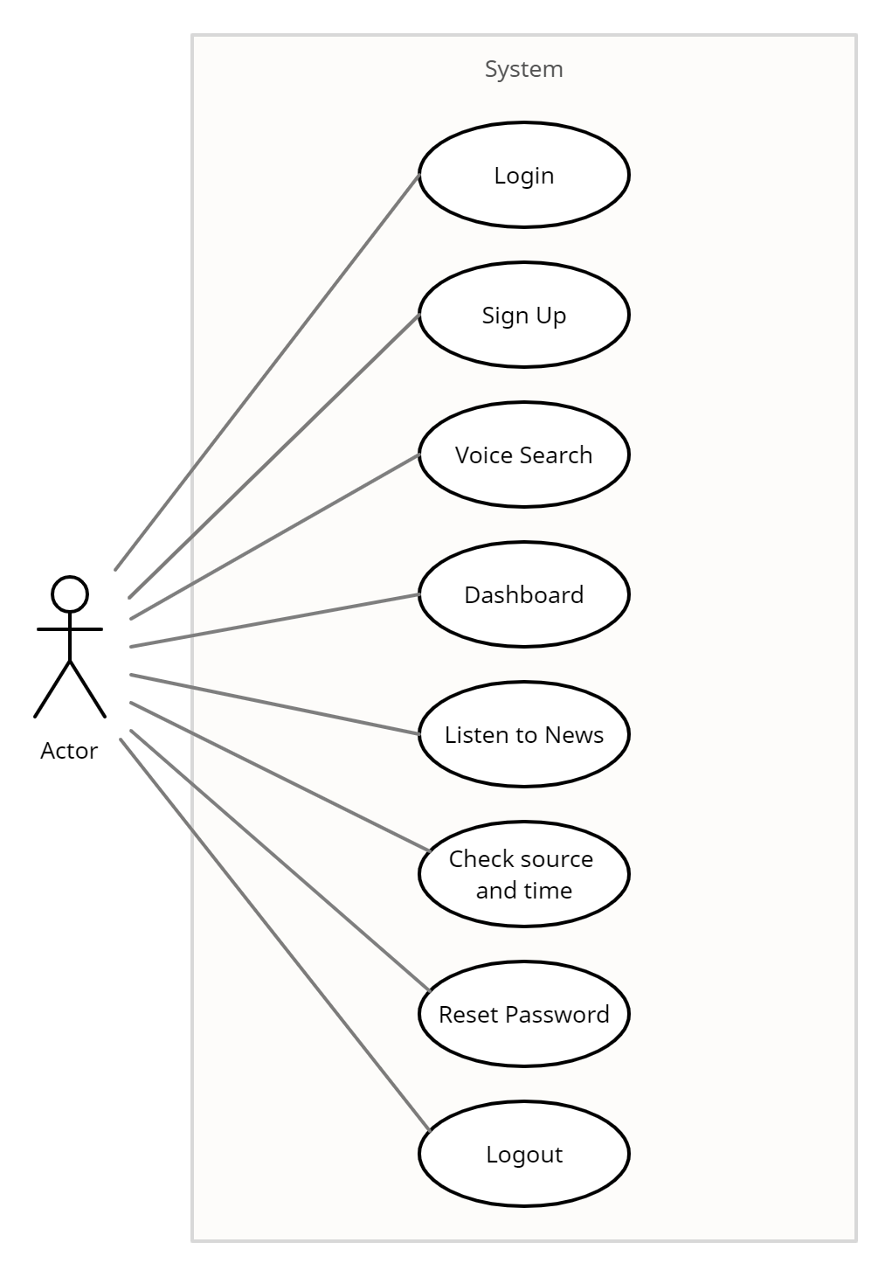

Database Schema:

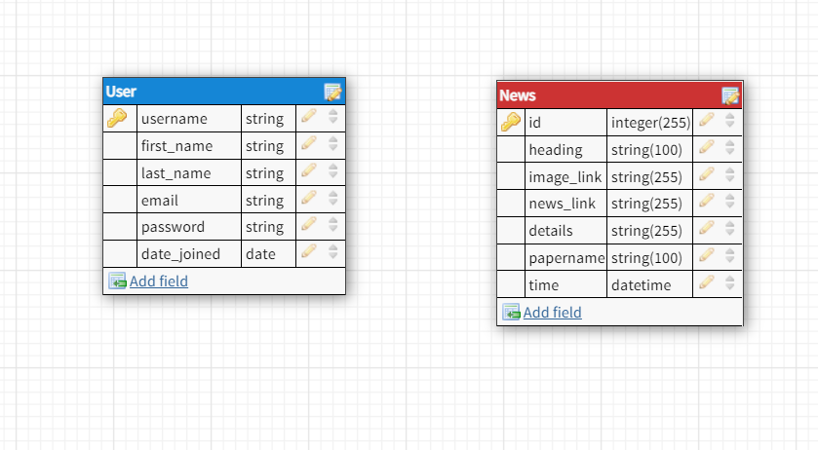

Use Case Details:

Title: Sign up

Actor: User

Scenario:

1. User can view Sign up page.

Exception:

1. Choosen username is not unique.
2. Choosen password is too weak.
3. Password doesn’t match with retype password.

Precondition:

1. User must have a device with internet connectivity.

Postcondition:

1. Successful: User can be able to login in the site.
2. Unsuccessful: Stays in same page.

Title: Login

Actor: User

Scenario:

1. User can view Login page.

Exception:

1. Username is not correct.
2. Password is not correct.

Precondition:

1. User must have a device with internet connectivity.
2. User must have signed up.

Postcondition:

1. Successful: User can access the site.
2. Unsuccessful: Stays in same page.

Title: Voice Search

Actor: User

Scenario:

1. User is logged in.
2. User has clicked on voice seach button.
3. User will speak their desired words.

Exception:

1. The site was not given permission to access microphone.

Precondition:

1. User must have a device with internet connectivity.
2. User must have a microphone.

Postcondition:

1. Successful: User will be shown the search result.
2. Unsuccessful: Stays in same page.

Title: Dashboard

Actor: User

Scenario:

1. User is logged in to the system.

Exception:

1. API is too busy.

Precondition:

1. User must have a device with internet connectivity.

Postcondition:

1. Successful: User will be shown the dashboard page.
2. Unsuccessful: Same page will be redirected.

Title: Listen to News

Actor: User

Scenario:

1. User has clicked on a details button of a specific news.

Exception:

1. The site was not given permission to access microphone.
2. API couldn’t convert the text to audio.

Precondition:

1. User must have a device with internet connectivity.
2. User must have a speaker.

Postcondition:

1. Successful: User will be able listen the specific news.
2. Unsuccessful: Stays in same page.

Title: Check News Source and Time

Actor: User

Scenario:

1. User has clicked on source button.

Exception:

1. The site couldn’t load source and time.

Precondition:

1. User must have a device with internet connectivity.
2. User must be logged in.

Postcondition:

1. Successful: User will be shown the source and time.
2. Unsuccessful: Stays in same page.

Title: Reset Password

Actor: User

Scenario:

1. User has clicked on Reset Password from Login page.

Exception:

1. Email is not matched with any associated account.

Precondition:

1. User must have a device with internet connectivity.
2. User must be signed up.

Postcondition:

1. Successful: User will be given a link to reset their password.
2. Unsuccessful: Stays in same page and ask user to input the email again.

Title: Logout

Actor: User

Scenario:

1. User has clicked on logout button.

Exception:

1. The site couldn’t log out.

Precondition:

1. User must have a device with internet connectivity.
2. User must be logged in.

Postcondition:

1. Successful: User will be logged out of the system.
2. Unsuccessful: Stays in same page.

UI Design:

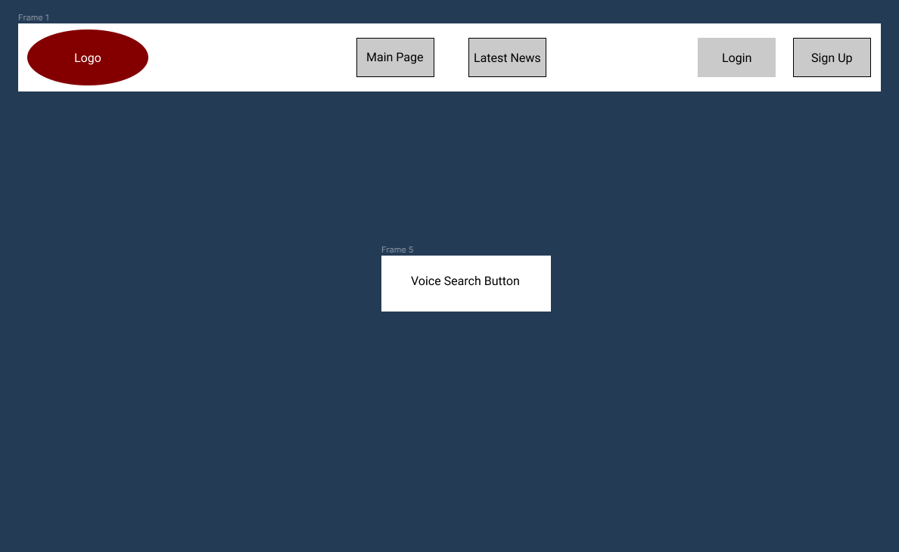Dashboard:

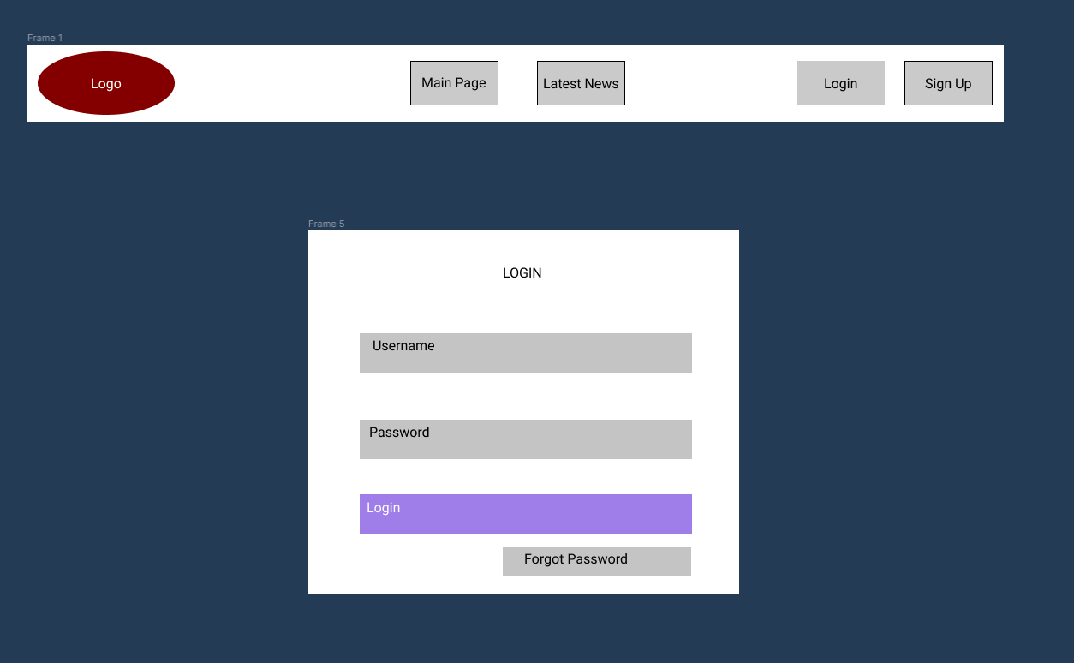Login:

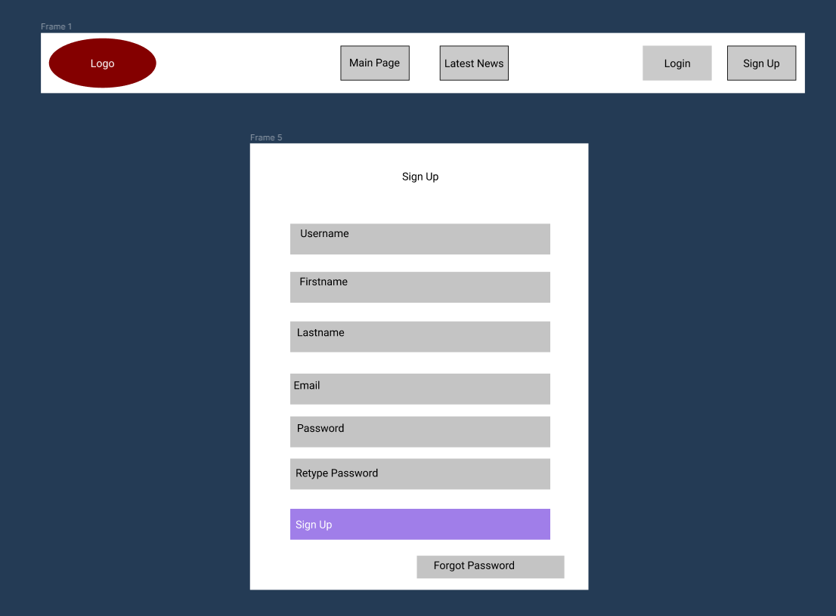Sign Up:

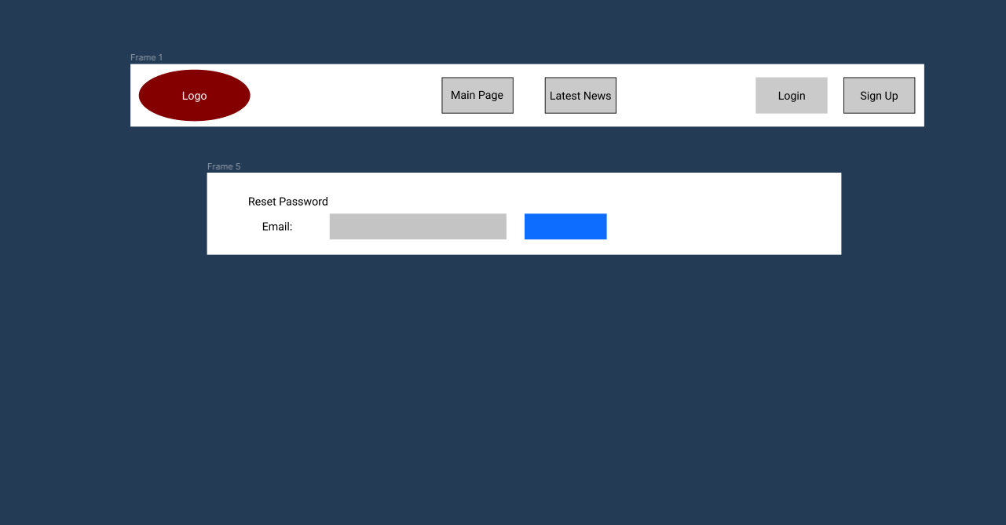Reset Password:

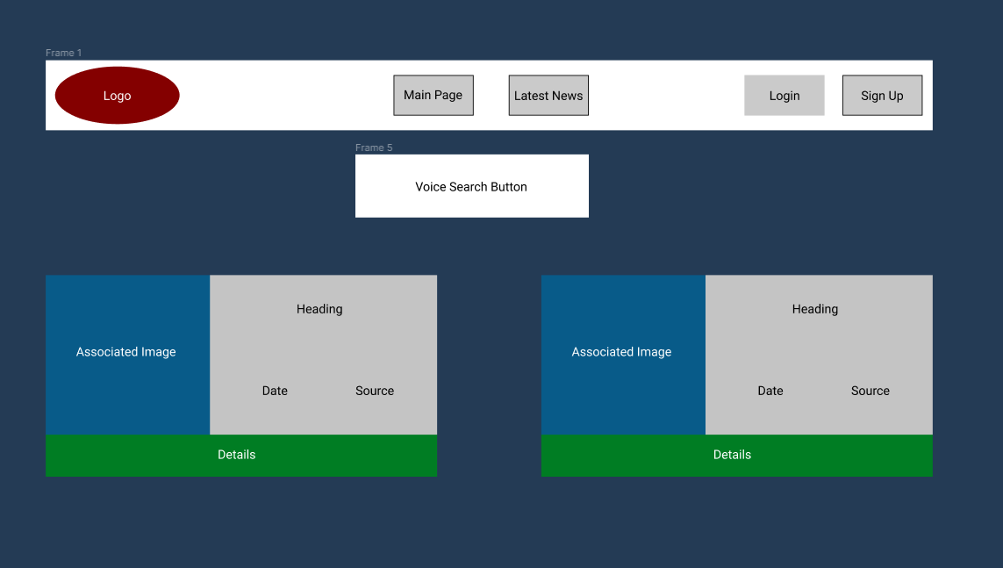Latest News: